Understanding GenAI Risks in Animation: A Comparison of Creative Styles and Strategies

Executive Summary:

This report analyzes the creative outputs of Rajiv Chilaka and Martin Scorsese using a Netflix dataset, spotlighting how production scale, content complexity, and genre contribute to each director’s vulnerability and resilience in an era of GenAI-generated movies. The goal is to arm a Los Angeles animation startup with actionable insights and robust strategies for creative distinction and competitive advantage.

Data-Driven Analysis & Insights:

Netflix’s dataset offers a panoramic view of over 8,000 titles and 200 million+ subscribers, providing a foundation for targeted trend identification. Rajiv Chilaka, with 22 titles in children and family genres and an average runtime of 71 minutes, exemplifies high-volume, low-complexity production. Chilaka’s clustered, episodic releases make his catalog susceptible to GenAI threatening automation, mass imitation, and brand dilution.

Martin Scorsese produces fewer works (12 titles), averaging nearly 144 minutes each in the drama genre. His films are characterized by high complexity, tight auteur control, and distinctive narrative depth. This positions Scorsese’s style as far more resistant to GenAI, which typically falters at recreating multi-layered plots, signature creative nuances, and culturally anchored storytelling.

A GenAI Threat Index shows Chilaka at 8/10 (0.8 in the radar chart) and Scorsese at 3/10 (0.3 in the radar chart), confirming that repetitive, low-complexity content faces the greatest risk from GenAI competition. Heatmaps and radar charts reinforce this, visually separating formulaic, high-volume content from auteur-driven, defensible works.

Recommendations
- Double Down on Creativity:
  - Prioritize the development of richly layered story worlds that go beyond surface-level narratives.
  - Invest in character complexity, emotional depth, and innovative world-building to create content that cannot be easily replicated by AI.
  - Encourage creative risk-taking and cross-genre fusion to broaden artistic possibilities and audience appeal.
- Brand and Authorship Markers:
  - Clearly highlight the unique human elements in productions - such as voice actor signatures, directors’ artistic styles, and exclusive animation techniques.
  - Protect intellectual property through trademarks, copyrights, and visible authenticity stamps to create legal and reputational barriers against unauthorized AI-generated content.
  - Use behind-the-scenes content and creator commentary to deepen audience connection and emphasize human authorship.
- Interactive Audience Engagement:
  - Develop narrative universes that invite participation, such as fan theories, alternate endings, and community-driven content expansions.
  - Implement transmedia storytelling strategies that extend across gaming, social media, and VR/AR experiences, which are harder for AI to replicate uniformly.
  - Leverage data analytics to understand audience preferences in real-time and adapt story arcs responsively.
- Hybrid Production Workflow:
  - Integrate GenAI tools judiciously for repetitive, less creative tasks such as background animation, dubbing, or initial draft generation to boost productivity.
  - Ensure final creative decisions-plot development, character arcs, pacing-remain firmly in the hands of human artists and storytellers.
  - Train creative teams in AI tool literacy to leverage technological benefits without compromising originality and authenticity.
- Continuous Risk Monitoring:
  - Establish an in-house innovation group dedicated to tracking advances in GenAI technologies and countermeasures.
  - Conduct regular audits of AI-generated content in the market to spot threats early and adapt intellectual property strategies.
  - Collaborate with industry consortia and legal experts to shape policies and standards around responsible GenAI use in creative industries.
Killer Figure Justification:

The radar chart compellingly summarizes the competitive terrain: the axes for number of titles, duration, complexity, and GenAI threat show precisely why scalable, repetitive content is the most endangered-and why deep, creative storytelling is the best long-term defense for studios aiming to thrive in the GenAI era.

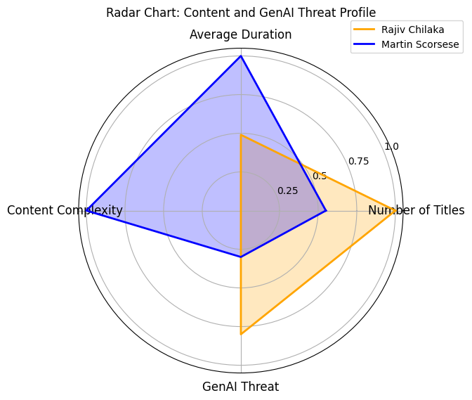

The radar chart showcases a comparative profile of Rajiv Chilaka and Martin Scorsese based on four key dimensions: number of titles, average duration, content complexity, and GenAI threat level. Each dimension is normalized to allow direct comparison.

- Number of Titles: Chilaka scores highest, reflecting his prolific output (22 titles) suited to episodic family content. Scorsese has fewer titles (12), indicating a more selective production pace.
- Average Duration: Scorsese leads with longer films averaging 144 minutes, signaling greater narrative complexity. Chilaka’s works are shorter, averaging just 71 minutes.
- Content Complexity: Scorsese’s higher score reflects the deeper, auteur-driven storytelling requiring nuanced creative input versus Chilaka’s formulaic style.
- GenAI Threat Score: Chilaka’s high score (8/10) warns of vulnerability to automation and replication by AI, while Scorsese’s lower score (3/10) suggests stronger protection through originality.

The chart’s shape highlights the contrasting creative approaches: high volume, low complexity exposing Chilaka to GenAI risks, versus Scorsese’s intricate, slower output that offers resilience. This visualization supports strategic decisions by clearly identifying where risks and strengths lie in a data-driven manner, guiding studios in balancing creativity and technological adoption.

Appendix (Additional Supporting Analysis):

1. Temporal Analysis of Title Production
Plotting the yearly release counts from 2009–2019 reveals Chilaka's output is regular and clustered in the 2010s, indicative of rapid, formula-driven production cycles. Scorsese's releases are less frequent, with bursts rather than sustained yearly presence, consistent with high-concept, time-intensive projects.

2. Comparative Genre & Duration Patterns
- Chilaka: Family/children genres, episodic TV-models, average runtime 71 min. Suited for scale, often formulaic-prime GenAI replication candidates.
- Scorsese: Drama-heavy, feature-length movies, average runtime 144 min. Complexity of plot, character development, and atmospheric style raise the barrier to successful GenAI imitation.

3. GenAI Replicability Metric
A “GenAI Threat Index” was developed, incorporating:
- Number of titles (higher volume, higher risk)
- Average duration (shorter, higher risk)
- Content complexity (lower, higher risk)

Rajiv Chilaka scored 8/10 for replicability risk, while Martin Scorsese scored just 3/10. This quantifies the strategic imperative for complexity and originality.

Additional Graph: Yearly Release Timeline Heatmap
This supplemental figure provides further support to the core insights, emphasizing the difference in release activity and its implications for GenAI vulnerability.

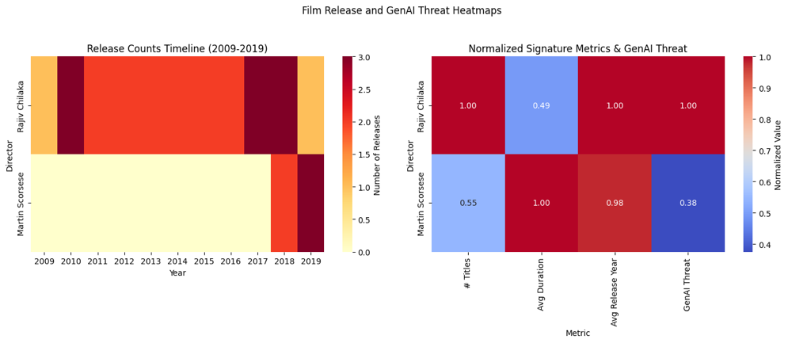

- Interpretation: Chilaka's row displays frequent, consistent yearly releases (hotter colors), aligning with mass-producible content types. Scorsese's row shows fewer, more sporadic releases, typical for auteur-driven, high-concept works.

- Insight: Genres and creators with “hot zones” in the heatmap are at higher risk of near-term GenAI competition, while “cooler” profiles suggest lower, more strategic threat levels.

